**Building a Chatbot – Project Description**

**Shivam Chauhan and Shubham Pratap Singh**

A bot is a software application that performs automated task and chatbots come under the category of bots that live in various chat platforms. A chatbot can converse with humans so the idea of conversation is primary to a chatbot.

The purpose of chatbots is to scale business teams and help them in maintaining a cordial relationship with their customers. This helps businesses cut down on operational costs, save time and ensure lucrative productivity as all the basic and monotonous requests are handled by the chatbot while complex queries are taken care of by the support team.

Advantages of Chatbots

1. Gather Customer Insights:

Chatbots can help you gather precious data from your customers by interacting with them. This includes getting insights about their activities, preferences, problems, and more.

2. Increase Sales:

You can use chatbots to offer immediate support to your potential customers. When their issues are resolved instantly, they may take your desired action as well. This could mean an increase in your lead generation, which can translate into more sales.

3. Available 24/7:

One of the biggest advantages of chatbots is that they’re available for your customers around the clock. Additionally, they answer promptly to every query that’s presented to them. This ensures that your customers will always find solutions to their problems, be it day or night.

4. Save Money:

If you don’t use chatbots, you need to pay your customer support team’s wages every month. This is a recurring expense that can be big if you have a large staff to respond to customers quickly. As your business grows, this expense will only increase.

5. Improve Customer Satisfaction:

The conversations that your customers have with your business matter a lot. Customer service executives may respond differently to your customers based on their mood. However, a chatbot abides by the rules that you’ve set for it. This ensures that it will respond in the exact manner that you want it to at any moment.

Disadvantages and Risks of Chatbots

1. Lack Emotions:

Bots can be too mechanical. With pre-programmed conversations, they can handle customer requests when the flow of the conversation follows a specific path. But they may not be able to handle when the conversation takes an unexpected turn.

2. Difficult to Create:

It is very challenging to create a chatbot from scratch. It requires that you invest significant time and effort into creating it. You may also need to have some coding knowledge to create a better-functioning chatbot.

3. Made to Handle First-Level Questions:

One of the greatest disadvantages of chatbots is that they have been designed to handle first-level questions only. They may not be able to solve complex queries.

4. Require Maintenance:

Chatbots require ongoing review, maintenance, and optimization in terms of their knowledge base and the way they are supposed to communicate with your customers.

For this project, we will be building a chatbot using deep learning techniques with the help of libraries such as Natural Language Toolkit (NLTK) and Keras in Python. We used Natural Language processing to process the text and will build an Artificial Neural Network to train our model. This project will be trained on the data from healthcare industry which have intents, input sentences and responses to their sentences.

Working example your project will look like this:

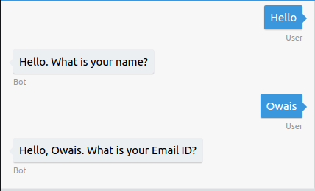

**For example: let say our all the words list is [‘hello’, ‘hi’, ‘bye’, ‘thank’, ‘you’]**

**And our classes list is [‘greeting’, ’goodbye’]**

**So, if the input text is ‘Thank you’. Our input for model will be a list [0,0,0,1,1].**

**Our output of model will be [0,1]**

**Now our model will understand that it must give a response from goodbye class. It will select a random response from the goodbye class in our data.**

*References:*

Shaikh, B. (2019, April 11). An Introduction to Chatbots. Retrieved from <https://chatbotslife.com/an-introduction-to-chatbots-8ca7d7ad2eb2>

Advantages and Disadvantages of Chatbots You Need to Know: Blog. (2019, December 5). Retrieved from <https://www.aivo.co/en/blog/advantages-and-disadvantages-of-chatbots-2/>